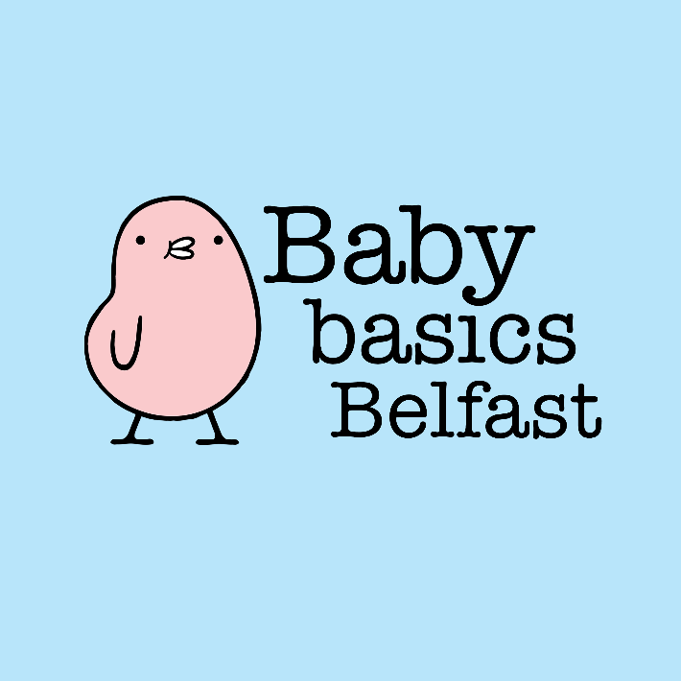
Contact Details:
Karen Webb
Mobile: 07803272628
Heather Gibson
Mobile: 07545207480
Email: babybasics@connordiocese.org

* Required field

Request Details
*Request made by

*Agency

Office phone number
*Mobile phone number
*Email address
*Preferred Completion date (Please put in a date that suits you to collect)
Client Details
*Name of Client
(First name or initials only is sufficient)
*Postcode (Just BT part)
Due Date
*Baby gender
(If known)
Is mum breastfeeding or planning to?
Any siblings?

Please select ONE of the following:
Items Requested | Needed
Moses’ basket starter pack

Moses’ basket (empty)

Starter pack - No basket

Baby Bath

Please select as many as are required of the following:
Baby bath support for use with adult bath
(Suitable for new- born)
Clothing bundle
(new-born or for other siblings in family-include sizes)
Nappies
(new-born or for other siblings in family-include sizes)
Toys
(new-born or for other siblings in family-include ages)
Toiletries for mum

Toiletries for dad

Other Equipment required (if available):

FYI ONLY: Our Starter packs will include:

For Mum | For Baby
Maternity pads | New-born nappies
Sanitary towels | Nappy lotion
Breast pads | Shampoo
Hand soap | Nappy bags
Shampoo | Wipes
Soap bags | Soap
Nipple Cream  (if breastfeeding) | Sponges/flannels
Hand cream | Cotton wool pads
Non-bio washing powder | Changing mat
Disposable briefs | New-born Clothing
 | Blankets

