Baby Basics Bromley
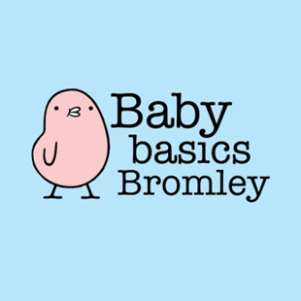
Referral Form

A referral can be made by any Health Professional or Agency who has identified a parent who is struggling to provide the essential equipment for their new baby.
(we may be able to support siblings up to the age of 2 depending on our stock)

Although we try and fulfill every order in full, we can only offer what we have had donated at that time.

Please complete the referral form below and e-mail to us – babybasicsbromley1@gmail.com
Once the referral is ready, we will email to inform you.
Referrals need to be collected by yourself or a team member, as soon as is practicably possible. Delivery can be arranged on special request.

Referral Request Details:

Date request made: ………………………………………………………………
Request made by (name): ………………………………………………………………
Agency type, please delete as necessary: Charity / Health Visitor / Local Council /
Multi agency support team / Midwife /Social worker / Other ………………
Agency name: ………………………………………………………………
Mobile / Office Phone Number: ………………………………………………………………
Email Address: ………………………………………………………………

Client Details:

Client initials: ………… Ethnicity ……………..

Client’s postcode: ……….

Number of children being referred …………
Baby Gender: Boy / Girl / Unknown Baby Due Date: …………………………
Child Gender: Boy/Girl/Unknown Child age(s): …………………………………………
Client situation - please underline/mark all that apply:
Seeking asylum Refugee No recourse to public funding
Cost of living Victim of Domestic Abuse Victim of trafficking
Mental Health Issues Homeless Young mother Other

Items requested:
Item | Please tick here if required & add any additional notes | Baby Basics use only Complete Checked
Moses basket with 0-3 month clothes
Moses basket – no clothes
Clothing bundle only (include size & gender)
Mum/ Baby / child toiletries bundle (note any specific toiletries required)
Nappies (include sizes)
Play mat
Toys (include age)
Steriliser (please identify microwave/electric)
Bottles
Sling/ carrier
NB: Items listed below may not always be available.
Baby bath
Bouncy Chair
Pram/ buggy
Changing mat
Changing bag
Feeding cushion
Double buggy
Any additional requests:

Most items we provide have been donated by the local community and are sorted, cleaned and packed by our volunteers. If you are ever unsure about the suitability or safety of any items, please do not issue to your clients. Please discuss any concerns you may have with the Baby Basics team. Thank you.
On collection signed by: ______________________________ Date: ______________

