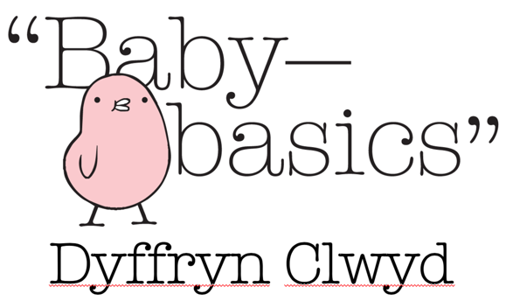

**Ffurflen Cais Newydd / New Request Form**

**BACHGEN / MERCH / NIWTRAL BOY / GIRL / NEUTRAL**

|  |  |  |  |  |  |  |  |
| --- | --- | --- | --- | --- | --- | --- | --- |
| **Dyddiad derbyn y cais\*** |  | | | **Date request made \*** | | | |
| **Derbynydd y cais \*** |  | | | **Request made by \*** | | | |
| **Math o Asiantaeth** |  | | | **Agency type** | | | |
| **Enw’r Asiantaeth** |  | | | **Agency Name** | | | |
| **Rhif ffôn swyddfa** |  | | | **Office phone Number** | | | |
| **Rhif ffôn symudol** |  | | | **Mobile Phone Number** | | | |
| **Cyfeiriad ebost** |  | | | **Email address** | | | |
|  |  | | | | | | |
| **Enw’r cleient** |  | | | **Client name** | | | |
| **Dyddiad disgwylir y babi** |  | | | **Due Date** | | | |
| **Cod Post y cleient** |  | | | **Client Postcode** | | | |
|  |  | | | | | | |
| **Eitemau ar gais Items requested** |  | | | | | | |
| **Pecyn cychwynnol Basged Moses**  Cynnwys basged moses, matres newydd, pethau molchi i mam a’r babi, dillad gwely a blancedi, tyweli a dillad hyd at 6 mis  **Moses Basket starter pack**  Includes Moses basket and new mattress, toiletries for mum and baby, bedding and blankets, towels, clothing up to 6 months | | | | | | |  |
| **Baby Bath Babi** | | | | | | |  |
| **Mat Newid / Changing Mat** | | | | | | |  |
| **Bag esgor** (Cynnwys eitemau mam a babi i fynd i’r ysbyty i eni’r babi)  **Labour bag** (Includes items for mum and baby for hospital visit to give birth) | | | | | | |  |
| **Bwndel o ddillad**  **Clothing Bundle (please tick age required)** | | **6-9m** | **9-12m** | | **12-18m** | **18-24m** | **2-3yrs** |
| **Arall Other** | | | | | | |  |

|  |
| --- |
| **Nodiadau**  **Notes** |

**\*Gwybodaeth angenrheidiol / Essential information**