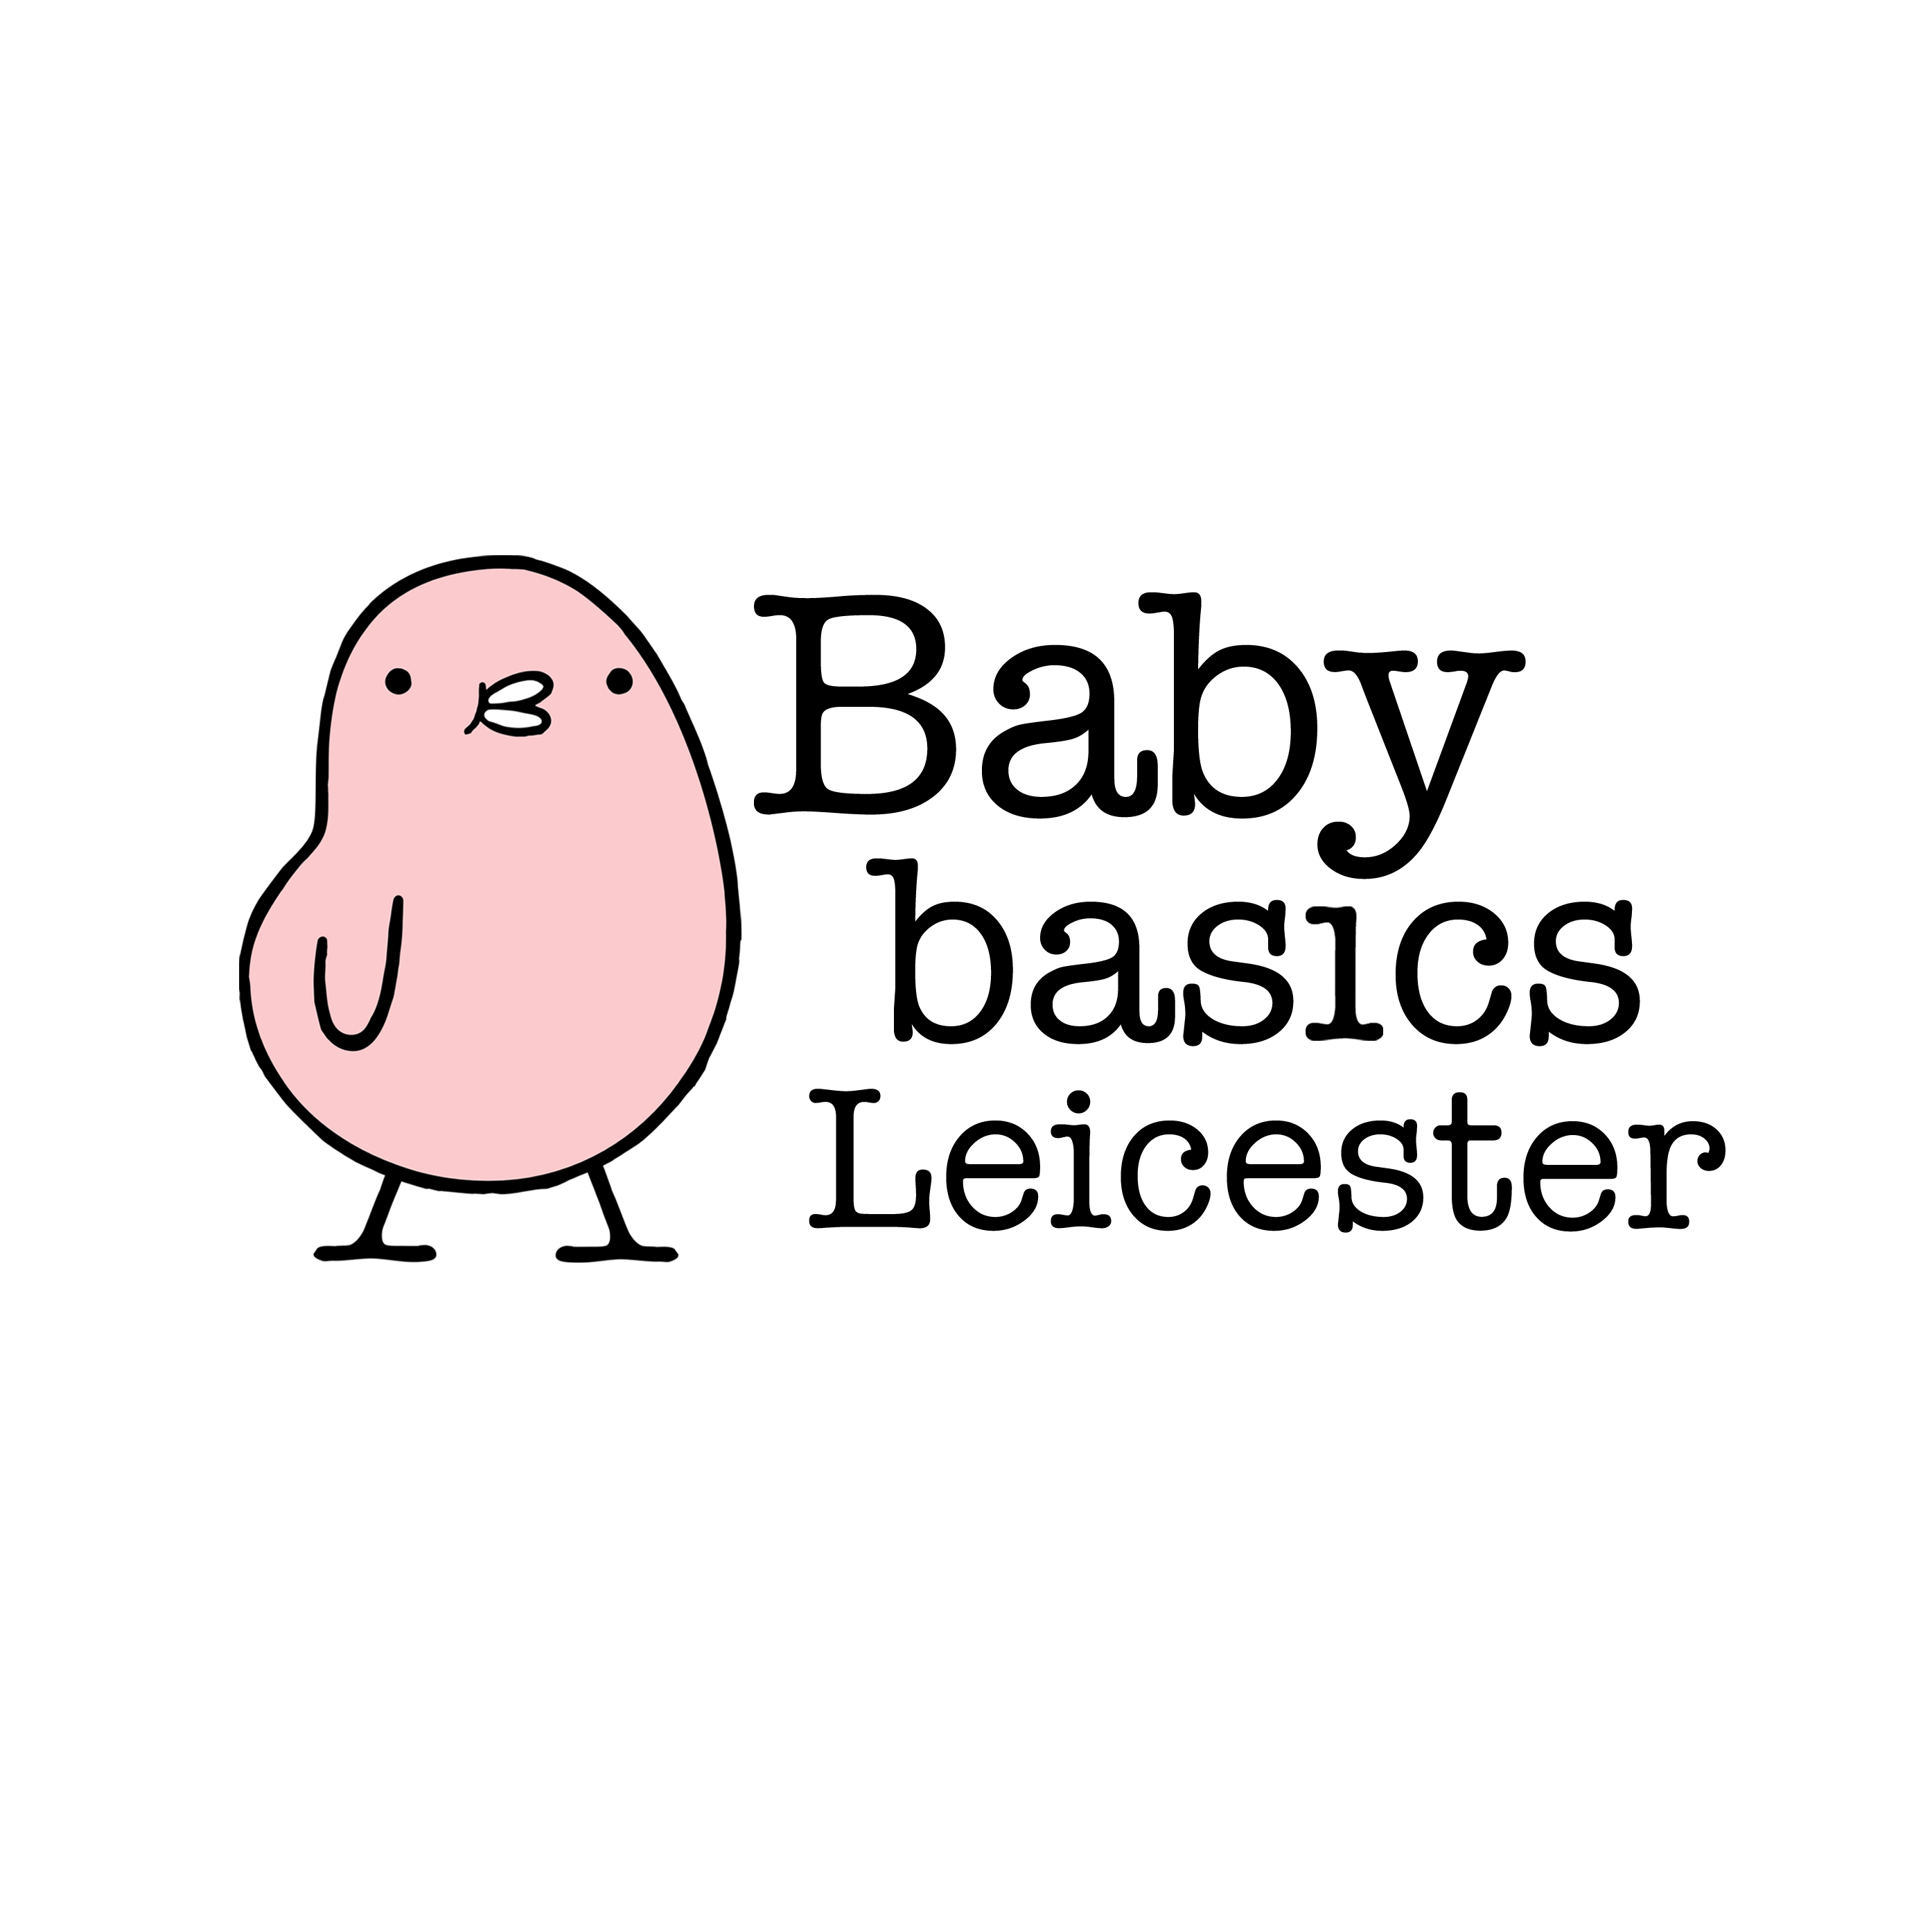

**Baby Basics Leicester**

**Making a Referral**

A referral can be made by any Health Professional or Agency who has identified a parent who is struggling to provide the essential equipment for a new baby, existing child (up to 5 years old) or themselves.

Although we try and fulfill every order in full, we can only offer what we have had donated at that time. At times there are waiting lists for larger items.

**To make a referral please complete the below form in full and e-mail to us.**

**Once the referral is ready, we will email to inform you. Referrals need to be collected by yourself or a team member, rather than the client, within two weeks of it being ready.**

**Referral Request Details:**

Date request made: ………………………………………………………………

Request made by (name): ………………………………………………………………

Agency type, please delete as necessary:

*Charity / Health Visitor / Local Council /*

*Multi agency support team / Midwife / Social worker*

Agency name: ………………………………………………………………

Mobile / Office Phone Number: ………………………………………………………………

Email Address: ………………………………………………………………

**Client Details:**

Client initials: ………………………………………………………………

Clients postcode : …………………………………………...

Baby Gender: Boy / Girl / Unknown

Baby Due Date/ Child’s age: ………………………………………………………………

Please underline/mark **all** that apply:

Seeking asylum/ Refugee Victim of Domestic Abuse Teenage parent

Victim of trafficking Cost of living Homeless

Mental Health Issues Other

**Items requested:**

|  |  |  |  |
| --- | --- | --- | --- |
| **Item** | **Please tick here if required**  **& add additional notes** | **Baby Basics use only** | |
| Moses basket starter pack |  |  |  |
| Starter pack – NO basket |  |  |  |
| Clothing bundle (include size & gender, shoe size if applicable) |  |  |  |
| Mum/ Baby / child toiletries bundle |  |  |  |
| Nappies (include size) |  |  |  |
| Baby bath |  |  |  |
| Toys & books bundle |  |  |  |
| Pram/ buggy  (there may be a waiting list) |  |  |  |
| Double buggy  (there may be a waiting list) |  |  |  |
| Sling/ carrier |  |  |  |
| Bouncy chair/ play mat (please specify) |  |  |  |
| High chair & weaning kit |  |  |  |
| Bottle bundle |  |  |  |
| Steriliser- Cold water/ Microwave (please specify) |  |  |  |
| Car seat (New) |  |  |  |
| Cot, mattress and bedding  (there may be a waiting list) |  |  |  |
| **Any further notes:** | | | |

* Please note the items in blue are the ones that we receive less frequently, which may not be available.

Most items given away from Baby Basics have been donated by members of the local community and are sorted and packed by our volunteer team. If you are ever unsure about the suitability or safety of any items given by Baby Basics please do not pass on to your clients. Please discuss any concerns you may have with the Baby Basics team. Thank you