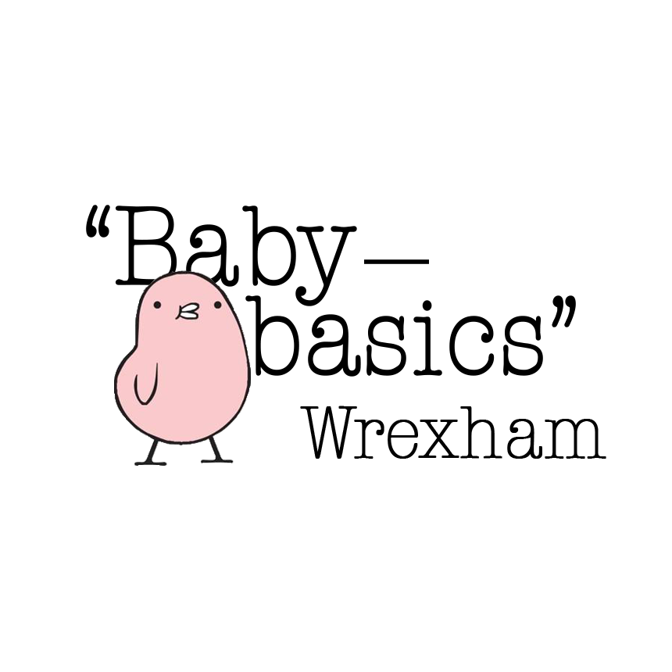

**New Request Form/Ffurflen Cais Newydd**

| **Date request made\*** |  | **Dyddiad derbyn y cais\*** | |
| --- | --- | --- | --- |
| **Request made by \*** |  | **Derbynydd y cais \*** | |
| **Agency type** |  | **Math o Asiantaeth** | |
| **Agency Name** |  | **Enw’r Asiantaeth** | |
| **Office phone Number** |  | **Rhif ffôn swyddfa** | |
| **Mobile Phone Number** |  | **Rhif ffôn symudol** | |
| **Email address** |  | **Cyfeiriad ebost** | |
|  |  | | |
| **Client Name** |  | **Enw’r cleient** | |
| **Due Date** |  | **Dyddiad disgwylir y babi** | |
| **Gender of baby (if known)** |  | **Rhyw y babi** | |
|  |  | | |
| **Items requested**  **Eitemau ar gais** | **Baby Bath**  **Bath Babi** | |  |
|  | **Moses Basket (empty)**  **Basged Moses (gwag)** | |  |
| **Moses Basket starter pack (with newborn clothing)**  **Pecyn cychwynnol Basged Moses (efo dillad newydd-anedig)** | |  |
| **Starter Pack (no moses basket)**  **Pecyn Cychwynnol (heb fasged moses)** | |  |
| **Clothing Bundle 0-3m**  **Bwndel o ddillad 3-6m**  **tiny baby** | |  |
| **Toiletries only (no hamper) Mum**  **Baby** | |  |
| **Nappies only (no hamper)** | |  |
| **Other**  **Arall** | |  |

| **Notes/Nodiadau:** |
| --- |

**\*Essential information/ Gwybodaeth angenrheidiol**