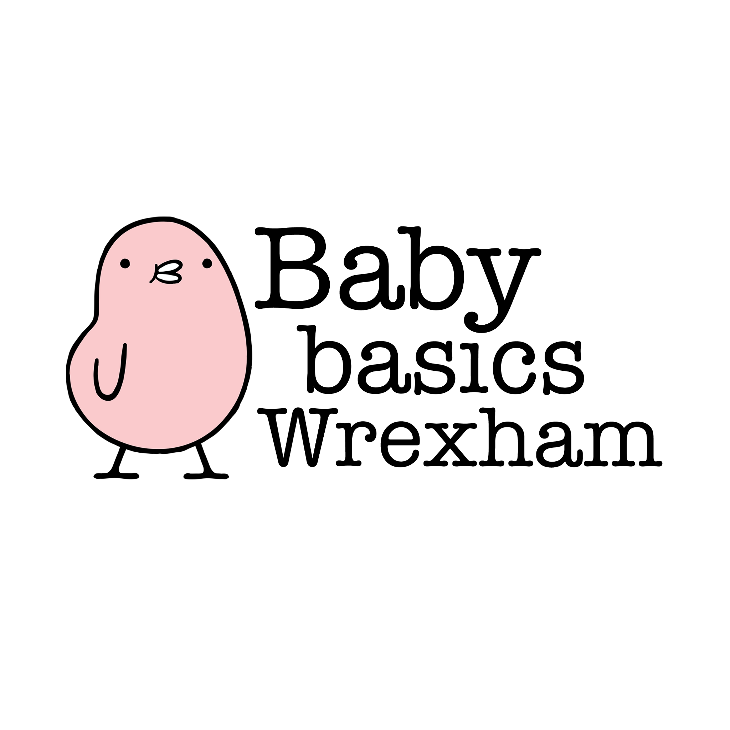

**New Request Form/Ffurflen Cais Newydd**

| **Date request made** |  | **Dyddiad derbyn y cais** | |
| --- | --- | --- | --- |
| **Request made by** |  | **Derbynydd y cais** | |
| **Agency type** |  | **Math o Asiantaeth** | |
| **Agency Name** |  | **Enw’r Asiantaeth** | |
| **Office phone Number** |  | **Rhif ffôn swyddfa** | |
| **Mobile Phone Number** |  | **Rhif ffôn symudol** | |
| **Email address** |  | **Cyfeiriad ebost** | |
|  |  | | |
| **Client Name** |  | **Enw’r cleient** | |
| **Due Date** |  | **Dyddiad disgwylir y babi** | |
| **Gender of baby (if known)** |  | **Rhyw y babi (os yn hysbys)** | |
| **Nursing/Bottle feeding  (if known)** |  | **Nyrsio/Bwydo potel  (os yw'n hysbys)** | |
| **Client postcode (for funding purposes)** |  | **Cod post cleient (at ddibenion ariannu)** | |
|  |  | | |
| **Items requested**  **Eitemau ar gais** | **Moses Basket starter pack (with newborn clothing)**  **Pecyn cychwynnol Basged Moses (efo dillad newydd-anedig)** | |  |
|  | **Starter Pack (no moses basket)**  **Pecyn Cychwynnol (heb fasged moses)** | |  |
| **Clothing Bundle 0-3m**  **Bwndel o ddillad 3-6m**  **tiny baby** | |  |
| ***ITEMS BELOW CAN BE REQUESTED IF NOT HAVING A STARTER PACK*** | | |
| **Moses Basket (empty)**  **Basged Moses (gwag)** | |  |
| **Toiletries only Mum/Mam**  **Offer ymolchi yn unig Baby/Babi** | |  |
| **Nappies only (indicate size preferred)**  **Clytiau yn unig (nodwch y maint a ffafrir)** | |  |
| **Toys/Teganau (0-6m or 6-12)** | |  |
| **Books/Llyfrau (0-6m or 6-12)** | |  |
| **Clothing Bundle 6-9m**  **Bwndel o ddillad 9-12m** | |  |
| **Other/Arall** | |  |

| **Notes/Nodiadau:** |
| --- |