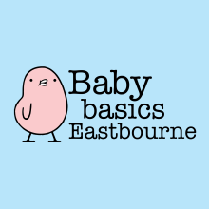

Required Items: Request Form

|  |  |
| --- | --- |
| Your name: | Your contact details: |
| Agency: | Date: |
| Client name: | Client postcode: |
| Ethnicity: | Number of children: |

Please indicate the items you require:

|  |  |
| --- | --- |
| Items | Please tick / add other information |
| Moses basket starter pack (includes clothing, toiletries, nappies, bedding & blankets) – please record gender |  |
| New mother labour bag (includes toiletries, maternity & breast pads) |  |
| Clothing bundles for children up to 5 years – please record gender and size |  |
| Age appropriate toy bundles (includes craft packs & books) – please record age of child and items taken |  |
| Feeding bottles |  |
| Steriliser |  |
| Breast pump |  |
| Baby sling |  |
| Sippy cup & weaning items |  |
| Highchair |  |
| Pushchair |  |
| Cot with new mattresses |  |
| Cot bedding |  |
| Travel cot |  |
| Moses basket - empty |  |
| Baby bath |  |
| Play gym |  |
| Bouncer chair |  |
| Potty |  |
| Other – please record items: | Collection signature: |