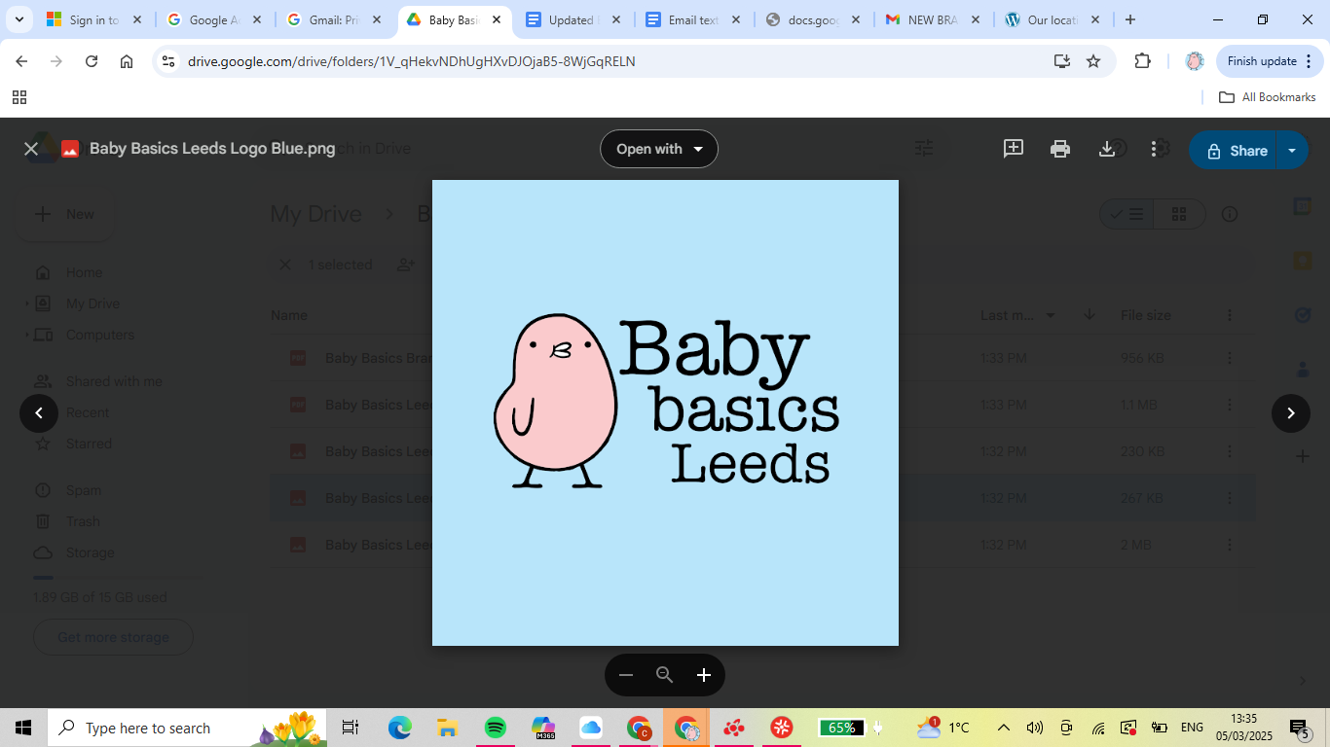**Baby Basics Leeds**

**Referral Form**

**Request Details**

| **Date of request:** |  | | | |
| --- | --- | --- | --- | --- |
| **Request made by:** |  | | | |
| **Agency type:** |  | | | |
|  | **Charity** |  | **NHS midwife** |  |
| **Prison Service** |  | **Multi Agency Support Team** |  |
| **Social worker** |  | **Local Council** |  |
| **Health visitor** |  | **Other (please specify):** |  |
|  |  | | | |
| **Agency name:** |  | | | |
| **Phone number:** |  | | | |
| **Email address:** |  | | | |
| **\*If referring from NHS midwifery services please include correct community team email relevant for client:** |  | | | |
| **Do you consent to us using the above information to fulfil this referral?** |  | | | |

**Client Details**

| **Client name/initials:** |  |  | | |  | |
| --- | --- | --- | --- | --- | --- | --- |
| **Due date or date of birth:** |  | **Date items needed:**  (1 month before due date) | | |  | |
| **Baby Gender (male/female/unisex):** |  | | | | | |
| **Additional information:** |  | | | | | |
|  | **Victim of trafficking** |  | **Prison inmate** | | |  |
| **Seeking asylum** |  | **Victim of domestic abuse** | | |  |
| **Teenage parent** |  | **Other (please specify e.g. low income)** | | |  |
|  |  |  | | | |
| **Does your client consent to us using the above information to fulfil this referral?** | | | |  | | |
| **Does your client need afro hair products (if available)? Yes/No/NA** | | | |  | | |

**Items Requested**

| **Moses basket starter pack** |  | **Starter pack - No basket** |  |
| --- | --- | --- | --- |
| **Empty Moses basket** |  | **Baby Bath** |  |
| **Moses basket stand (if available)** |  | **3-6 months clothing bundle** |  |
| **6-9 months clothing bundle** |  | **9-12 months clothing bundle** |  |
|  |  |  |  |
| **Hospital Bag\***  **\*if requesting a bag please specify size to aid packing appropriate items, if the size is not shown please input and we will aim to source.** |  |  |  |
| **Maternity nightie (sizes S, M, L, XL)** |  | **S=8-10, M=10-12, L=14-16, XL=16-18** |  |
| **Nursing bra (sizes S, M, L, XL and colour preference if available)** |  | **see chart below as a guide**  **Nude/white/black/colourful** |  |
| **Knicker (sizes S, M, L )** |  | **S=8-10, M=12-14, L=16-18** |  |
| **Flipflops (sizes S, L )** |  | **S=UK size 5 or under, L=UK size 6 or above** |  |

**Notes**

|  |
| --- |

**Please note we do not contact the client directly, all referrals must be collected by the referring agency. We endeavour to fulfil all referrals as requested but may differ slightly if donations are reduced.**

Baby Basics Leeds is based out of St Paul’s Church, Ireland Wood, Leeds, LS16 6BS.

Email:[babybasicsleeds@gmail.com](mailto:babybasicsleeds@gmail.com) Phone: 07970724408

<https://baby-basics.org.uk/>

[www.facebook.com/babybasicsleeds](http://www.facebook.com/babybasicsleeds)

