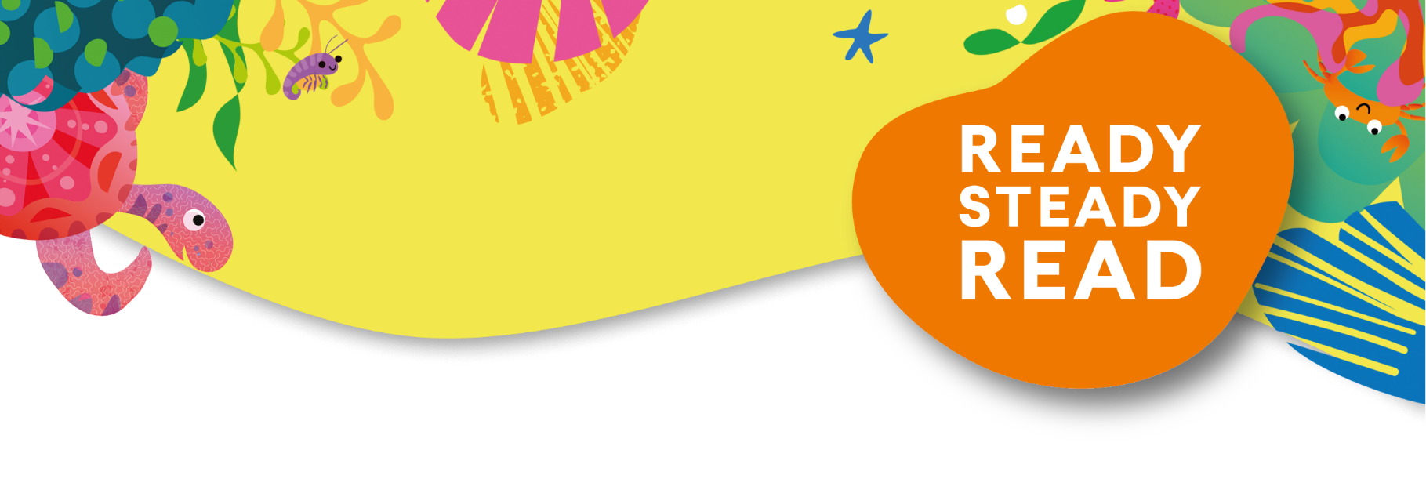
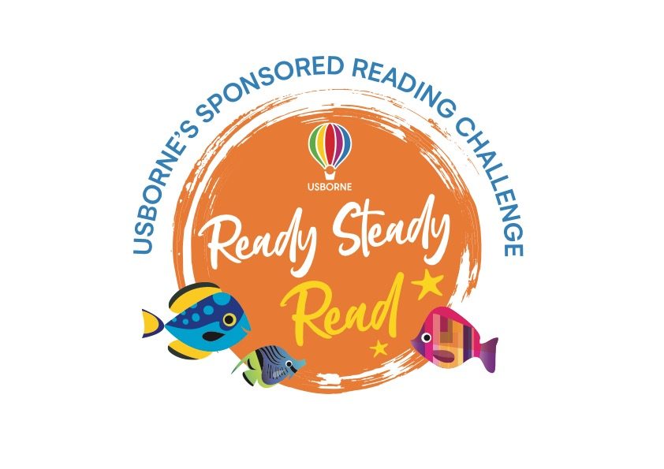

Sponsorship form

Reader Name:

Name | Sponsorship  (per minute or total donation) | Amount collected

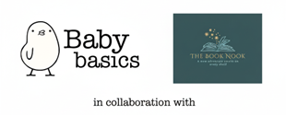

Total amount:
Please send a copy of this form along with your reading log to thebooknook2012@gmail.com to receive your certificate!

Please add all sponsorship money to the JustGiving Page - https://www.justgiving.com/crowdfunding/thebooknook-babybasics

